**Members**

Lisa Chen

**File Listing**

* **searchAgents.py** 
  + File defining search agents and search problems
  + Only CornersHeuristic method implemented
  + Added a helper method calcManhattanDist()

**What I’ve learned**

I tried to use manhattan distance for the closest corner as implementing directly from the instructions. However, it didn’t yield the best score with 1475 while the aim was to get less than 1200. Since there are 4 corners though, I thought maybe to implement the heuristic by calculating the heuristic using manhattan distance to every corner if Pacman went to the closest corner first every time. This was able to achieve a score much lower than just using one corner (score: 434)

Question 6: Pacman Terminal Prints

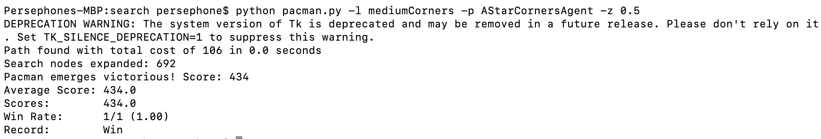

Autograder Question 6

